Rules and Regulations for Text Products

1. Product roles
- Space Weather Outlook: Provides broader-horizon forecast information and early awareness.
- Space Weather Statement: Provides an early heads-up, addresses activity below Warning criteria, communicates event ramp-down, or provides a warning-level all-clear. A Statement may formally end a Warning and transition partners back toward normal monitoring.
- Space Weather Watch: Indicates that G3 or greater conditions are possible within the defined preparation horizon.
- Space Weather Warning: Indicates that G3–G5 conditions are expected or occurring within the defined response horizon.
- Warning Update: Reassesses the same Warning no later than 12 hours after the previous Warning or Warning Update, and sooner when observations, timing, intensity, duration, impacts, or confidence materially change.
- Observed Space Weather Alert: Confirms a detected event or the first attainment of an observed threshold. It supplements and does not replace a forecast Warning.
- Space Weather Summary: Synthesizes a complex ongoing event, documents major developments, and provides final event closure when the event ends.
- Space Weather Notice: Communicates technical, analytical, data-quality, service, or coordination information. It is not a hazard-severity tier and does not independently change an active hazard assessment.
- Space Weather Advisory: Eliminated from the public product system. The name is retained only where ICAO requirements specifically require an Advisory.

2. Headline rules
For geomagnetic products:
- Do not include G-scale numbers in the headline.
- State the hazard, product status, and valid period.
- Use plain language that matches the purpose of the product.
- Do not use the graduated descriptors Minor, Moderate, Strong, Severe, or Extreme.
- Major is the only approved severity modifier and applies to G4 and greater conditions.
- Do not place secondary or lower-probability escalation scenarios in the headline.
- Do not introduce geographic or timing precision that is not supported elsewhere in the product.
Examples:
...GEOMAGNETIC ACTIVITY POSSIBLE FROM…
...SPACE WEATHER WATCH IN EFFECT FOR GEOMAGNETIC STORM CONDITIONS…
...SPACE WEATHER WARNING REMAINS IN EFFECT FOR ONGOING AND RENEWED
MAJOR GEOMAGNETIC STORM...

3. Time rules
Our locked format is: HHMM UTC Ddd Mon DD YYYY
Therefore:
- Use four-digit, 24-hour UTC everywhere.
- Every time in the body follows the same format as the issuance header.
- Repeat the complete timestamp at both ends of an interval.
- Do not use today, tonight, tomorrow, midday, midnight, Friday evening, or similar relative language.
- Keep these separate:
  - Issuance time
  - Observation time
  - Valid period
  - Most-likely onset/arrival
  - Earliest/latest or plausible window
  - Expected event end
  - Product expiration or replacement
  - Next-update time
- A most-likely arrival time is not the valid-period start.
- The end of an arrival window is not the expected end of storm conditions.
- Every continuing product must provide an exact next-update deadline.

4. Probability rules
- Use a single numeric probability, not a range.
- Round only to scientifically supportable increments—normally 5% or 10%.
- Every probability must identify:
  - The event or threshold
  - The domain or applicable area
  - The start and end of the valid period
  - Whether it is conditional on another event
- Distinguish among:
  - Probability of coronal mass ejection arrival
  - Probability of G-level attainment
  - Probability of a specified duration
  - Conditional probability of intensity given arrival
- Do not publish a raw ensemble-member percentage as a calibrated probability.
- Threshold probabilities must be monotonic:
  - P(G3+) ≥ P(G4+) ≥ P(G5)
- Do not use 0% or 100% unless the outcome is impossible, observed, or effectively certain.
- Avoid vague standalone wording such as possible, likely, may, or could when a numerical probability exists.
- Never minimize consequential outcomes with wording such as only a 10% chance.

5. Terminology and scale rules
The revised public terminology is:
- G: Geomagnetic Storm
- SP: Solar Particle Storm
- SF: Solar Flare
Additional rules:
- Use particle in the public hazard name and identify proton flux in the technical definition.
- Spell out coronal mass ejection in public text rather than using CME by itself.
- Do not treat the G level as a direct forecast of local geomagnetically induced currents or specific equipment consequences.
- Distinguish the global hazard from the location and severity of potential impacts.
The graduated descriptors are removed:
- Minor
- Moderate
- Strong
- Severe
- Extreme
Major is introduced at:
- G4 and above
- P3 and above
- L3 and above
Therefore:
- G3 may support Watch or Warning coverage but does not carry the Major modifier.
- Do not write combinations such as G3 (Strong), G4 (Severe), G5 (Extreme), or severe to extreme in newly drafted products.
- Legacy text quoted for historical or prototype purposes must not be treated as revised-scale precedent.

6. Message structure
Forecast products should generally contain:
Headline / WHAT / WHERE / WHEN / CONFIDENCE / IMPACTS / PRECAUTIONARY/PREPAREDNESS ACTIONS or PARTNER ACTIONS / ADDITIONAL DETAILS / NEXT UPDATE
Observed Alerts additionally require:
OBSERVED / BASIS / CURRENT STATUS / FUTURE ALERTS
Space Weather Summaries use:
EVENT OVERVIEW / WHAT HAS OCCURRED / CURRENT STATUS / WHAT IS EXPECTED, when the event remains active / IMPACTS / ACTIVE PRODUCTS or ADDITIONAL DETAILS / NEXT SUMMARY

7. Impact wording
- Impacts must match the forecast or observed level and relevant sectors.
- Use consequence language proportionally: effects are possible, not guaranteed.
- Do not copy the entire generic scale impact description into every product.
- Distinguish global hazard extent from where impacts are most likely or consequential.
- Identify exposure modifiers such as latitude, geology, duration, system design, shielding, altitude, or local conditions when relevant.
- Solar Particle Storm messaging must not imply that the ≥10 MeV proton scale directly measures human radiation dose.
- Aurora statements must remain conditional on darkness, clouds, and viewing conditions when those qualifications matter.
- Calls to action must be specific, authorized, and proportional to the product function.

Timeline Table - Gannon Storm - 06-16 May, 2024
Issuance time | Product | Purpose / event stage | Status
1500 UTC Mon May 06 2024 | Space Weather Outlook | Broader-horizon forecast and early awareness | Included
0630 UTC Wed May 08 2024 | Space Weather Statement | Solar eruption under analysis | Included
1600 UTC Wed May 08 2024 | Space Weather Statement | Geomagnetic activity possible | Included
0800 UTC Thu May 09 2024 | Space Weather Watch | Geomagnetic storm conditions possible | Included
1300 UTC Thu May 09 2024 | Space Weather Notice | Delayed coronagraph imagery | Included
1230 UTC Fri May 10 2024 | Space Weather Warning | Geomagnetic storm conditions expected | Included
1647 UTC Fri May 10 2024 | Observed Space Weather Alert | Sudden impulse following coronal mass ejection arrival | Included
1722 UTC Fri May 10 2024 | Observed Space Weather Alert | First G3 threshold attainment | Included
Time not specified | Observed Space Weather Alert — G4 | First G4 threshold attainment | Placeholder—not created
2058 UTC Fri May 10 2024 | Observed Space Weather Alert | First G5 threshold attainment | Included
0030 UTC Sat May 11 2024 | Warning Update Number 1 | Ongoing major geomagnetic storm | Included
1230 UTC Sat May 11 2024 | Warning Update Number 2 | Ongoing and renewed storm risk | Included
1400 UTC Sat May 11 2024 | Space Weather Notice | Coronagraph contamination during solar particle storm | Included
1800 UTC Sat May 11 2024 | Space Weather Summary Number 1 | Mid-event synthesis | Included
0030 UTC Sun May 12 2024 | Warning Update Number 3 | Required 12-hour reassessment | Placeholder—not created
1230 UTC Sun May 12 2024 | Warning Update Number 4 | Required 12-hour reassessment | Placeholder—not created
0000 UTC Mon May 13 2024 | Space Weather Statement | Ramp-down; Space Weather Warning ended | Included
1200 UTC Tue May 14 2024 | Space Weather Statement | Warning-level all-clear | Included
1600 UTC Thu May 16 2024 | Space Weather Summary Number 2 | Final event summary and closure | Included

Note: IDSS briefings would begin with the Watch and be updated daily or as needed, typically alongside Warning Updates. Four email briefings will be created for the exercise: an initial broad core-partner briefing with the Watch; an updated broad core-partner briefing with the first Warning; a focused power-grid briefing with Warning Update #2; and a final broad core-partner briefing accompanying the all-clear.

Partner specific briefing based on threshold (for example P(G5) > 15%))

Space Weather Outlook
Gannon storm reconstruction — representative prototype
Proposed Product

SPACE WEATHER OUTLOOK
National Weather Service Space Weather Prediction Center Boulder CO
1500 UTC Mon May 06 2024

...ACTIVE SPACE WEATHER CONDITIONS EXPECTED THROUGH
0000 UTC MON MAY 13 2024...

.DAY ONE...1500 UTC Mon May 06 2024 through
0000 UTC Tue May 07 2024

Solar activity is expected to remain elevated. L2-L3 solar flare
activity is expected, with intermittent HF radio degradation on the
sunlit side of Earth. Additional L3 or greater flare activity is
possible from the large, complex active regions on the visible disk.

Periods of G1-G2 geomagnetic storming are possible. Potential effects
include degraded HF communication at higher latitudes, increased GNSS
uncertainty in disturbed ionospheric regions, increased
low-Earth-orbit satellite drag, and expanded aurora visibility where
darkness and local viewing conditions allow.

SP1 or greater solar particle storm conditions are possible if
additional L3 or greater flares occur.

.DAYS TWO THROUGH THREE...0000 UTC Tue May 07 2024 through
0000 UTC Thu May 09 2024

Solar flare activity remains the primary concern. L2 activity is
likely, and L3 activity remains possible. Geomagnetic activity is
expected to decrease from Mon May 06 2024 levels, although unsettled
to active periods may continue.

.DAYS FOUR THROUGH SEVEN...0000 UTC Thu May 09 2024 through
0000 UTC Mon May 13 2024

Active Region 3664 remains large, complex, and capable of additional
eruptions. Further Earth-directed coronal mass ejections are possible, but confidence in any late-period Earth impacts remains low
at issuance time.

.PARTNER INFORMATION STATEMENT...

Partners should monitor SWPC updates through
0000 UTC Mon May 13 2024. A Space Weather Statement, Watch, or Warning
may be issued if confidence increases for consequential geomagnetic,
particle, or flare activity.

$$

WHY THIS PROPOSAL HELPS
A structured Outlook preserves rapid weekly awareness while making the forecast drivers, time horizon, and escalation path clear.
- Explains the solar, geomagnetic, and particle environment rather than presenting scale values alone.
- Separates the near-term forecast from later-period uncertainty and identifies the potential for further eruptions.
- Creates an auditable pre-event record without inventing unsupported numerical probabilities.

Space Weather Statement — eruption under analysis
Gannon storm reconstruction — representative prototype
Proposed Product

WAXX22 KWNP 080630
SWSXXX

SPACE WEATHER STATEMENT
National Weather Service Space Weather Prediction Center Boulder CO
0630 UTC Wed May 08 2024

...SOLAR ERUPTION UNDER ANALYSIS...

* WHAT...A significant solar flare occurred early this morning from a
large, complex active region. A coronal mass ejection may have been
produced.

* WHERE...Worldwide and Earth's orbit.

* WHEN...Potential Earth impacts are possible later this week. Timing
remains uncertain while imagery and model analysis continue.

* CONFIDENCE...Low. Early imagery and the location of the eruption
suggest an Earth-directed component is possible.

* IMPACTS...If an Earth-directed coronal mass ejection is confirmed,
geomagnetic activity could affect HF communications, satellite
navigation, satellite operations, and electric power systems, particularly at
high latitudes.

* ADDITIONAL DETAILS...No Space Weather Watch or Warning is in effect
for this event at this time. A Space Weather Watch may be issued if
additional imagery and model guidance indicate possible significant
impacts to Earth.

* NEXT UPDATE...No later than 1800 UTC Wed May 08 2024, or sooner if
conditions change.

$$

WHY THIS PROPOSAL HELPS
An early-analysis Statement gives partners an authoritative status while SWPC determines whether an eruption is Earth-directed.
- Confirms that SWPC has identified the event and analysis is underway.
- States what is known, what remains unresolved, and when the next update will arrive.
- Establishes a clear path to a Watch without prematurely requesting operational action.

Special Weather Statements heighten awareness of ongoing, imminent, or developing conditions. This proposed use applies that established NWS function to the early, still-uncertain phase of a space weather event. NWSI 10-517

Space Weather Statement — G1-G2 conditions
Gannon storm reconstruction — representative prototype
Proposed Product

WAXX22 KWNP 081600
SWSXXX

SPACE WEATHER STATEMENT
National Weather Service Space Weather Prediction Center Boulder CO
1600 UTC Wed May 08 2024

...GEOMAGNETIC ACTIVITY POSSIBLE FROM 1200 UTC FRI MAY 10 2024 THROUGH 1200 UTC MON MAY 13 2024...

* WHAT...Geomagnetic storm (G1-G2) likely.

* WHERE...Worldwide and Earth's orbit. Higher-latitude regions are most
likely to experience operational effects.

* WHEN...There is a 50% chance that G1 or greater conditions will begin
between 1800 UTC Fri May 10 2024 and
0600 UTC Sat May 11 2024.

Earliest Storm Onset: 1200 UTC Fri May 10 2024
Latest Storm Onset: 1200 UTC Sun May 12 2024

Minimum Duration: 12 hours
Maximum Duration: 24 hours

* CONFIDENCE...There is a 60% chance that the peak will reach G2 and a 10% chance that it will reach G3 or greater.

* IMPACTS...Power grids may experience small voltage changes or alarms.
Increased drag may reduce the accuracy of low-Earth-orbit satellite
predictions. Long-distance HF communication may fade at higher
latitudes. Aurora may expand across more of the northern United States
where darkness, clouds, and local viewing conditions allow.

* ADDITIONAL DETAILS...Solar activity remains high. The forecast for
elevated geomagnetic activity is based on two coronal mass ejections,
but additional eruptions are possible. No Space Weather Watch or Warning
is in effect at 2200 UTC Wed May 08 2024. A Watch may be issued if
confidence increases for G3 or greater conditions. Partners and the
public should continue to monitor SWPC products for updated information.

* NEXT UPDATE...No later than 1000 UTC Thu May 09 2024, or sooner if
conditions change.

$$

WHY THIS PROPOSAL HELPS
A G1-G2 Statement preserves early awareness while keeping the action level proportional to the anticipated hazard.
- Provides an explicit onset window, plausible bounds, and duration.
- Separates onset probability from conditional storm-intensity probabilities.
- Explains impacts, escalation criteria, and the next decision point.

This Statement carries lower-level hazard information below Watch and Warning criteria while preserving a defined escalation path. NWSI 10-517

Ensemble guidance

Runs 56381 and 56382 have fit/median arrivals near 2244 UTC Fri May 10 2024 and 2348 UTC Fri May 10 2024. Their centers are about one hour apart, increasing confidence that the primary onset window is from 1800 UTC Fri May 10 2024 through 0600 UTC Sat May 11 2024. Closely spaced coronal mass ejection effects are possible. The public probability is a forecaster assessment informed by the ensemble, not a raw member fraction.

Space Weather Watch — G3-G4 conditions possible
Gannon storm reconstruction — representative prototype
Proposed Product
WOXX22 KWNP 090800
WATA50

URGENT - SPACE WEATHER MESSAGE
SPACE WEATHER WATCH
National Weather Service Space Weather Prediction Center Boulder CO
0800 UTC Thu May 09 2024

...SPACE WEATHER WATCH IN EFFECT FOR GEOMAGNETIC STORM CONDITIONS FROM 1200 UTC FRI MAY 10 2024 THROUGH 0600 UTC MON MAY 13 2024...

* WHAT...Geomagnetic storm (G3-G4) possible.

* WHERE...Worldwide and Earth's orbit. Higher-latitude regions face the greatest potential impacts.

* WHEN...There is a 70% chance that storm onset will occur between
1800 UTC Fri May 10 2024 and 0600 UTC Sat May 11 2024.

Earliest Storm Onset: 1200 UTC Fri May 10 2024
Latest Storm Onset: 0600 UTC Sat May 11 2024

Minimum Duration: 12 hours
Maximum Duration: 48 hours

* CONFIDENCE...There is a 65% chance of G3 or greater conditions and a
20% chance of G4 or greater conditions.

* IMPACTS...Power systems may experience voltage-control issues,
transformer stress, and isolated equipment trips. Atmospheric drag
may lower satellite orbits and reduce the accuracy of tracking and
orbit predictions. HF communication, precision satellite navigation,
and some satellite communications may be intermittently degraded,
particularly at higher latitudes. Geomagnetically induced currents
may affect pipeline monitoring and corrosion-control systems. Aurora
may be visible across much of the United States where darkness and
local viewing conditions allow.

PRECAUTIONARY/PREPAREDNESS ACTIONS...

Partners should review sector-specific procedures, monitor SWPC
updates, and consult relevant decision-support guidance.

* ADDITIONAL DETAILS...Additional ensemble members indicate possible
coronal mass ejection influences beyond the primary onset window. A
Warning may be issued if G3 or greater conditions become expected.

* NEXT UPDATE...No later than 2000 UTC Thu May 09 2024, or sooner if
conditions change.

$$

WHY THIS PROPOSAL HELPS
A Watch reserved for possible G3 or greater conditions gives partners a clear preparation signal before warning criteria are met.
- Pairs the most-likely onset window with earliest and latest plausible timing.
- Uses monotonic G3-or-greater and G4-or-greater probabilities.
- Translates the forecast into preparation actions and sector-specific consequences.

Ensemble guidance

The ensemble signal has strengthened from one or two possible arrivals into a multi-disturbance scenario. Runs 56381, 56382, and 56385 indicate Earth-arriving disturbances, with primary fit/median arrivals from 2244 UTC Fri May 10 2024 through 0623 UTC Sat May 11 2024.

Runs 56381 and 56382 are tightly grouped near 2244 UTC Fri May 10 2024 and 2348 UTC Fri May 10 2024. Run 56385 centers near 0623 UTC Sat May 11 2024. The wider ensemble spread extends from 1200 UTC Fri May 10 2024 into Sun May 12 2024, supporting a focused most-likely onset window while retaining broader uncertainty in subsequent influences.

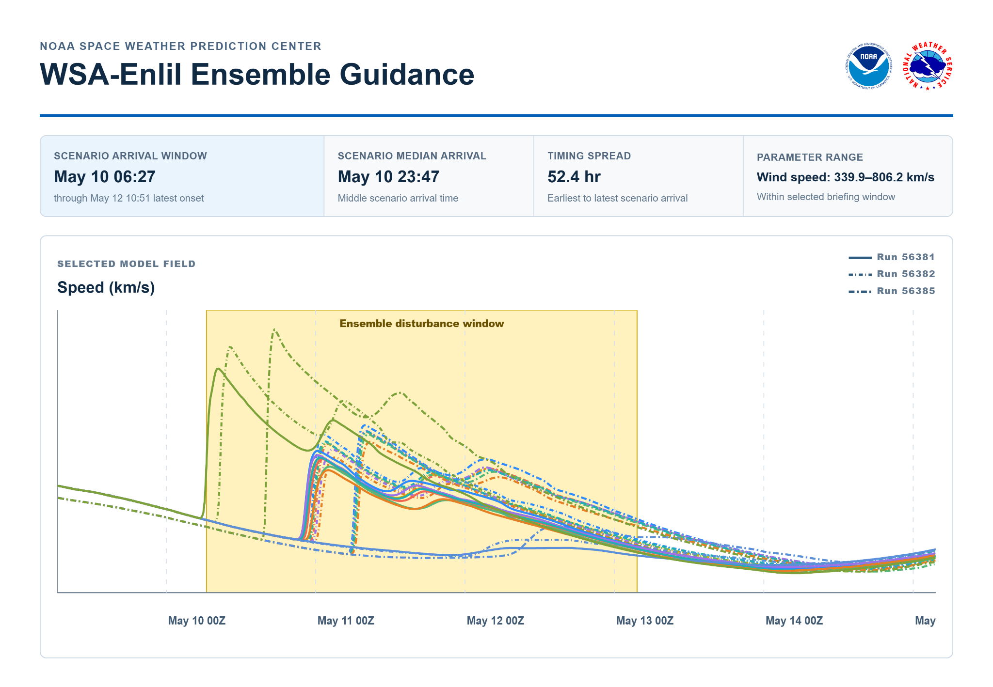

Space Weather Notice — delayed coronagraph imagery
Gannon storm reconstruction — representative prototype
Proposed Product

SPACE WEATHER NOTICE
National Weather Service Space Weather Prediction Center Boulder CO
1300 UTC Thu May 09 2024

...CORONAGRAPH IMAGERY AVAILABILITY AFFECTING CORONAL MASS
EJECTION ANALYSIS...

* WHAT...Coronagraph imagery needed for additional coronal mass ejection
analysis has not updated since 0905 UTC Thu. SWPC is continuing to analyze
recent eruptions using the imagery and guidance available at
1300 UTC Thu May 09 2024.

* IMPACTS...Confidence in the exact arrival timing, duration, and strength
of potential coronal mass ejection impacts may be reduced until
additional imagery becomes available. The overall forecast continues
to support elevated to significant geomagnetic activity from
1200 UTC Fri May 10 2024 into Sat May 11 2024.

* ADDITIONAL DETAILS...The active Space Weather Watch remains in effect.
This Notice describes a forecast-data limitation and does not change
the hazard assessment.

* NEXT UPDATE...The imagery limitation will be addressed in the next
Space Weather Watch update no later than
2000 UTC Thu May 09 2024, or sooner if availability changes.

$$

WHY THIS PROPOSAL HELPS
A Space Weather Notice makes forecast-data limitations visible without changing the active hazard product.
- Explains exactly which observation is delayed and which forecast elements may be less precise.
- Prevents users from interpreting reduced data quality as a reduction in hazard.
- Defines when and where SWPC will provide the next status update.

Space Weather Warning — G3-G5
Gannon storm reconstruction — representative prototype
Proposed Product
WOXX22 KWNP 101230
WATA50

URGENT - SPACE WEATHER MESSAGE
SPACE WEATHER WARNING
National Weather Service Space Weather Prediction Center Boulder CO
1230 UTC Fri May 10 2024

...SPACE WEATHER WARNING IN EFFECT FOR GEOMAGNETIC STORM CONDITIONS FROM 1200 UTC FRI MAY 10 2024 THROUGH 0600 UTC MON MAY 13 2024...

* WHAT...Geomagnetic storm (G3-G4) expected.

* WHERE...Worldwide and Earth's orbit. Middle- and higher-latitude regions
face the greatest potential effects.

* WHEN...There is a 65% chance that storm onset will occur between
1800 UTC Fri May 10 2024 and 0000 UTC Sat May 11 2024.

Earliest Storm Onset: 1200 UTC Fri May 10 2024
Latest Storm Onset: 0600 UTC Sat May 11 2024

Minimum Duration: 24 hours
Maximum Duration: 48 hours

* CONFIDENCE...There is an 85% chance of G3 or greater conditions,
including a 5% chance of G5 conditions.

* IMPACTS...Power systems may experience voltage-control issues,
transformer stress, and isolated equipment trips. Atmospheric drag
may lower satellite orbits and reduce the accuracy of tracking and
orbit predictions. HF communication, precision satellite navigation,
and some satellite communications may be intermittently degraded,
particularly at higher latitudes. Geomagnetically induced currents
may affect pipeline monitoring and corrosion-control systems. Aurora
may be visible across much of the United States and potentially
farther south where darkness and local viewing conditions allow.

PRECAUTIONARY/PREPAREDNESS ACTIONS...

Partners should prepare for significant geomagnetic activity, follow
sector-specific procedures, and maintain heightened situational
awareness through 0030 UTC Sat May 11 2024.

* ADDITIONAL DETAILS...This Warning replaces the previous Space Weather
Watch. Additional coronal mass ejection influences may produce
renewed geomagnetic activity from 0000 UTC Sat May 11 2024 through
0600 UTC Mon May 13 2024.

* NEXT UPDATE...No later than 0030 UTC Sat May 11 2024, or sooner if
conditions change.

$$

WHY THIS PROPOSAL HELPS
A single event-based Warning gives users time to act before G3-G5 impacts begin.
- Replaces a stream of technical K-index messages with one coherent hazard assessment.
- Distinguishes the probability of storm occurrence from the probability of the narrower onset window.
- Provides severity, duration, impacts, partner actions, and an exact update deadline.

Ensemble guidance supporting the Warning

Runs 56381 and 56382 show closely clustered fit/median arrivals near 2244 UTC Fri May 10 2024 and 2348 UTC Fri May 10 2024. Run 56385 adds an expected arrival near 0623 UTC Sat May 11 2024, and run 56387 extends the concern to near 0159 UTC Sun May 12 2024. Together, the runs support a multi-disturbance sequence rather than a single short-duration event.

The operational signal is that multiple disturbances are favorably positioned to reach Earth within a compressed period, with additional influence possible into Sun May 12 2024. That supports escalation to a Warning because the event has a credible path to G3-G4 conditions, with a lower-probability G5 outcome.

The ensemble supports the Warning's most-likely onset window while retaining earlier and later bounds. A Warning issued at 1230 UTC Fri May 10 2024 would provide about four hours of lead time before upstream shock detection at 1639 UTC Fri May 10 2024 and the sudden impulse at 1645 UTC Fri May 10 2024.

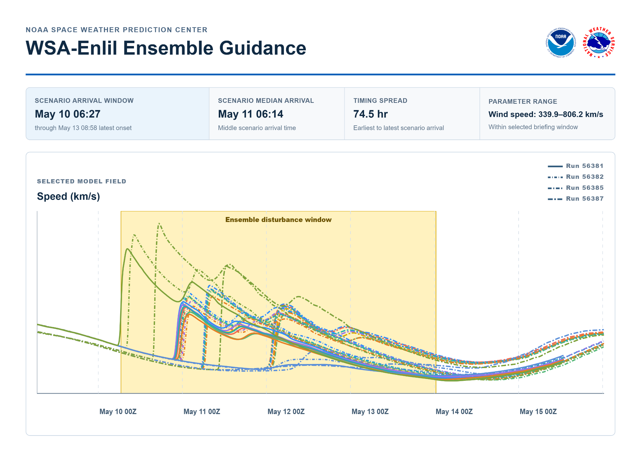

Observed Space Weather Alert — sudden impulse
Gannon storm reconstruction — representative prototype
Proposed Product

OBSERVED SPACE WEATHER ALERT
National Weather Service Space Weather Prediction Center Boulder CO
1647 UTC Fri May 10 2024

...SUDDEN IMPULSE OBSERVED FOLLOWING CORONAL MASS EJECTION
ARRIVAL...

* WHAT...A geomagnetic sudden impulse has been observed.

* OBSERVED...The sudden impulse was observed at 1645 UTC Fri May 10 2024 following detection of an interplanetary shock in the upstream solar wind at 1639 UTC Fri May 10 2024.

* BASIS...This alert is based solely on real-time upstream solar wind
measurements available at 1647 UTC Fri May 10 2024.

* CURRENT STATUS...Solar wind conditions are becoming strongly enhanced
following shock arrival. Geomagnetic activity is expected to increase
as the disturbance moves past Earth. A Space Weather Warning remains
in effect for G3-G5 conditions.

* FUTURE ALERTS...This alert confirms arrival of a coronal mass
ejection-driven disturbance. Additional Observed Space Weather Alerts
will be issued when geomagnetic activity first reaches G3, G4, or G5.

* IMPACTS...The sudden impulse may produce rapid magnetic-field changes
and marks the beginning of potentially significant geomagnetic
activity. Power grid, satellite, GNSS, HF radio, and other magnetically
sensitive operations should prepare for worsening conditions.

PRECAUTIONARY/PREPAREDNESS ACTIONS...

Partners should begin heightened monitoring, follow sector-specific
procedures, and monitor SWPC Warning Updates, Observed Space Weather
Alerts, and decision-support guidance.

$$

WHY THIS PROPOSAL HELPS
An Observed Space Weather Alert correctly identifies the sudden impulse as confirmation of arrival rather than a forecast Warning.
- Connects upstream shock detection and the ground response to the active forecast.
- Signals the transition from preparation to heightened monitoring.
- Explains which first-threshold alerts will follow as the event escalates.

Observed Space Weather Alert — G3
Gannon storm reconstruction — representative prototype
Proposed Product

OBSERVED SPACE WEATHER ALERT
National Weather Service Space Weather Prediction Center Boulder CO
1720 UTC Fri May 10 2024

...GEOMAGNETIC STORM CONDITIONS OBSERVED...

* WHAT...Geomagnetic activity has reached the G3 (Strong) level.

* OBSERVED...G3 conditions were observed at 1720 UTC during the
1500-1800 UTC observation period.

* BASIS...This alert is based on 12/13 real-time observations from the
official Kp magnetometer network available at the time of issuance.

* CURRENT STATUS...A Space Weather Warning remains in effect for
significant geomagnetic activity. Major conditions remain possible.

* FUTURE ALERTS...This is the first and only G3 Observed Space Weather
Alert that will be issued for this event. A new Observed
Space Weather Alert will be issued if conditions escalate to G4 or
G5.

* IMPACTS...Power systems may experience voltage irregularities or
false alarms on some protection devices. HF radio communication may
be intermittent at high latitudes. GNSS users may experience increased
uncertainty or degraded performance in disturbed ionospheric regions.
Low-Earth-orbit satellites may experience increased drag. Aurora may
be visible farther south than usual if local sky conditions allow.

PRECAUTIONARY/PREPAREDNESS ACTIONS...

Partners should continue heightened monitoring and follow
sector-specific procedures. Power grid, aviation, satellite, GNSS, and
HF radio users should continue to monitor SWPC Warning Updates and
decision-support guidance.

$$
WHY THIS PROPOSAL HELPS
One Observed Space Weather Alert at first G3 attainment records meaningful escalation without repeated threshold notifications.
- Reduces alert fatigue by suppressing duplicate G3 alerts.
- Links the observation to the continuing Warning and possible G4-G5 escalation.
- Places ongoing conditions in Warning Updates and Summaries, where context can be preserved.
Prototype continuity — G4 Observed Space Weather Alert
An Observed Space Weather Alert would have been issued when the proposed 12-station Kp application first confirmed G4 conditions. Its full prototype is intentionally omitted because it would mirror the demonstrated G3 and G5 structures.

Observed Space Weather Alert — G5
Gannon storm reconstruction — representative prototype
Proposed Product

OBSERVED SPACE WEATHER ALERT
National Weather Service Space Weather Prediction Center Boulder CO
2058 UTC Fri May 10 2024

...MAJOR GEOMAGNETIC STORM CONDITIONS OBSERVED...

* WHAT...Geomagnetic activity has reached the G5 (Extreme) level.

* OBSERVED...G5 conditions were observed at 2058 UTC during the
2100-2400 UTC observation period.

* BASIS...This alert is based on 12/13 real-time observations from the
official Kp magnetometer network available at the time of issuance.

* CURRENT STATUS...A Space Weather Warning remains in effect.

* FUTURE ALERTS...This is the first and only G5 Observed Space Weather
Alert that will be issued for this event. Continued major storm
conditions will be communicated through Warning Updates.

* IMPACTS...Power systems may experience widespread voltage-control
issues, increased geomagnetically induced currents, and protective
system concerns. HF radio communication may be degraded or unavailable
over some paths. GNSS users may experience degraded accuracy, loss of
lock, or other performance issues in disturbed ionospheric regions.
Low-Earth-orbit satellites may experience significantly increased
drag. Aurora may be visible much farther south than usual if local sky
conditions allow.

PRECAUTIONARY/PREPAREDNESS ACTIONS...

Partners should follow sector-specific procedures for extreme
geomagnetic activity. Power grid, aviation, satellite, GNSS, and HF
radio users should maintain heightened situational awareness and monitor
SWPC Warning Updates, Space Weather Summaries, and decision-support
guidance.

$$

WHY THIS PROPOSAL HELPS
One event-level G5 Alert confirms that the storm reached the highest G-scale level without repeatedly notifying users.
- Creates a clear historical marker for peak observed severity.
- Provides operational context, expected continuation, and partner actions.
- Keeps repeated G5 periods in Warning Updates and Summaries instead of generating alert fatigue.

Space Weather Warning Update Number 1
Gannon storm reconstruction — representative prototype
Proposed Product
WOXX22 KWNP 110030
WATA50

URGENT - SPACE WEATHER MESSAGE
SPACE WEATHER WARNING UPDATE NUMBER 1
National Weather Service Space Weather Prediction Center Boulder CO
0030 UTC Sat May 11 2024

...SPACE WEATHER WARNING REMAINS IN EFFECT FOR MAJOR GEOMAGNETIC STORM CONDITIONS THROUGH 1200 UTC SUN MAY 12...

* WHAT...Major (G4-G5) geomagnetic storm is ongoing.

* WHERE...Worldwide and Earth's orbit. Middle- and higher-latitude
regions are most likely to experience the greatest effects.

* WHEN...Warning-level geomagnetic activity is ongoing. There is a
75% chance of continued G3 or greater conditions through Saturday.

Earliest Warning End: 1200 UTC Sat May 11 2024
Latest Warning End: 1200 UTC Sun May 12 2024

Shortest Remaining Duration: 12 hours
Longest Remaining Duration: 36 hours

* CONFIDENCE...There is a 45% chance of additional G4 periods, with a 20% chance of additional G5 periods.

* IMPACTS...Power systems may experience voltage-control issues,
transformer stress, and isolated equipment trips. Increased
atmospheric drag may lower satellite orbits and reduce the accuracy
of satellite tracking and orbit predictions. HF radio, precision
satellite navigation, and some satellite communications may be
intermittently degraded, particularly at middle and higher latitudes.
Geomagnetically induced currents may also affect pipeline monitoring
and corrosion-control systems. Aurora may be visible across much of
the United States and potentially into some southern areas.

PRECAUTIONARY/PREPAREDNESS ACTIONS...

Partners should continue heightened operations, follow sector-specific
procedures, and monitor SWPC updates and decision-support guidance.

* ADDITIONAL DETAILS...G5 conditions were first observed at
2058 UTC Fri May 10 2024, and Warning-level activity remains ongoing.
This update continues the existing Space Weather Warning. Additional
solar disturbances may produce renewed periods of severe to extreme
geomagnetic activity into Sunday.

* NEXT UPDATE...No later than 1230 UTC Sat May 11 2024, or sooner if
conditions change.

$$

WHY THIS PROPOSAL HELPS
Warning Update Number 1 provides a stand-alone reassessment after the storm reaches G5 while retaining the familiar product structure.
- The WHEN section communicates the probability of continued warning-level activity and provides clear bounds for when the Warning may end.
- The CONFIDENCE section distinguishes high confidence in continued significant activity through Saturday from greater uncertainty about additional disturbances into Sunday.
- The ADDITIONAL DETAILS section documents the observed G5 escalation, confirms that the Warning remains in effect, and explains the potential for renewed activity.
- The defined warning-end window supports staffing and mitigation decisions, while the NEXT UPDATE establishes when partners can expect another reassessment.

Ensemble guidance

By 0030 UTC Sat May 11 2024, the product is no longer a pure forecast: G5 has been observed and warning-level activity is ongoing. Runs 56381 and 56382 have moved from forecast support into the observed event environment, so the update blends the observed escalation with remaining ensemble-supported guidance.

Runs 56385, 56387, and 56396 support continued concern after the initial onset. Their fit/median arrivals center near 0623 UTC Sat May 11 2024, 0159 UTC Sun May 12 2024, and 1750 UTC Sun May 12 2024. This supports continued Warning coverage and renewed-impact concern into Sun May 12 2024.

The 75% probability of continued G3 or greater conditions through 0000 UTC Sun May 12 2024 is a forecaster-assessed value based on the observed storm response plus the remaining sequence of expected impacts. It is not a direct Kp probability or a raw ensemble-member fraction.

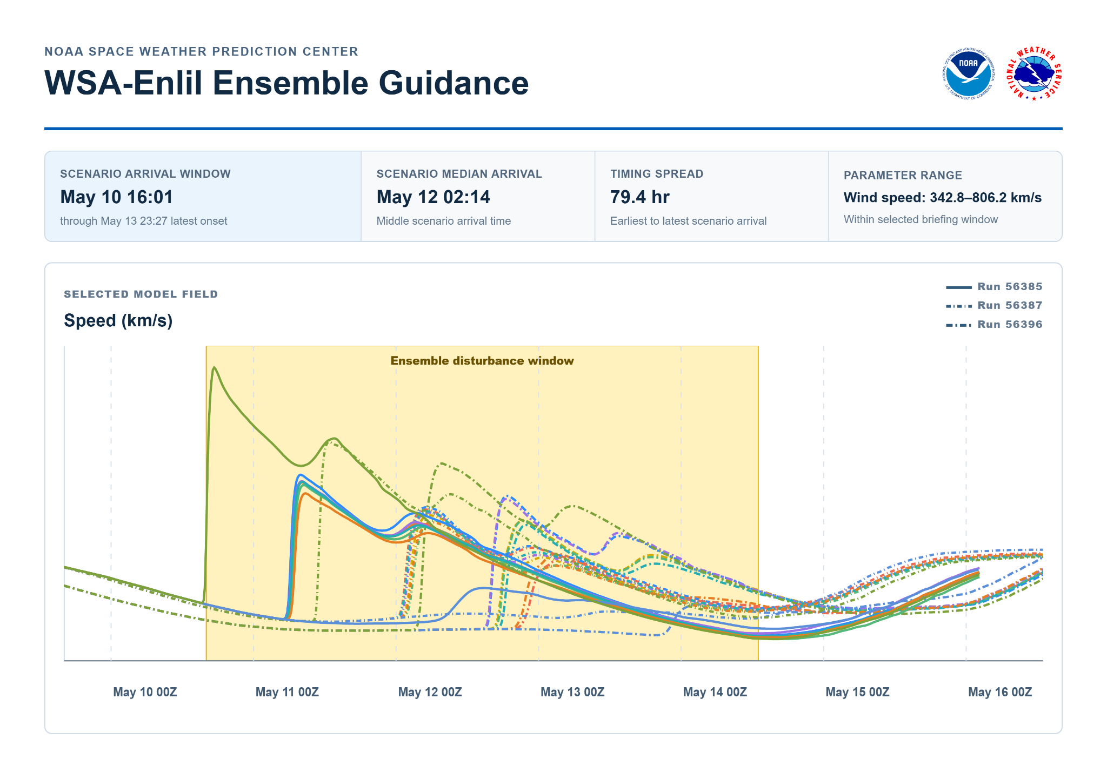Partner Specific Briefing

Space Weather Warning Update Number 2
Gannon storm reconstruction — representative prototype
Proposed Product
WOXX22 KWNP 111230
WATA50

URGENT - SPACE WEATHER MESSAGE
SPACE WEATHER WARNING UPDATE NUMBER 2
National Weather Service Space Weather Prediction Center Boulder CO
1230 UTC Sat May 11 2024

...SPACE WEATHER WARNING EXTENDED DUE TO ONGOING AND POSSIBLE RENEWED
MAJOR GEOMAGNETIC STORM THROUGH 1800 UTC SUN MAY 12...

* WHAT...Major (G4-G5) geomagnetic storm remains possible.

* WHERE...Worldwide and Earth's orbit. Middle- and higher-latitude
regions are most likely to experience the greatest effects.

* WHEN...Geomagnetic storms are ongoing. There is an 80% chance of
renewed CME impact between 0600 UTC Sun May 12 and 1800 UTC Sun May 12.

Most Likely Renewed Impact: 1200 UTC Sun May 12
Earliest Renewed Impact: 0600 UTC Sun May 12
Latest Renewed Impact: 1800 UTC Sun May 12

Shortest Duration: 12 hours
Longest Duration: Beyond 0000 UTC Mon May 13

* CONFIDENCE...There is a 60% chance of G3 conditions following renewed impact and a 20% chance of G4.

* IMPACTS...Power systems may experience voltage-control issues,
transformer stress, and isolated equipment trips. Increased
atmospheric drag may lower satellite orbits and reduce the accuracy
of satellite tracking and orbit predictions. HF radio, precision
satellite navigation, and some satellite communications may be
intermittently degraded, particularly at middle and higher latitudes.
Geomagnetically induced currents may also affect pipeline monitoring
and corrosion-control systems. Aurora may be visible across much of
the United States and potentially into some southern areas.

PRECAUTIONARY/PREPAREDNESS ACTIONS...

Partners should continue heightened operations, follow sector-specific
procedures, and monitor SWPC updates and decision-support guidance
through 1200 UTC Sun May 12.

* ADDITIONAL DETAILS...Another series of coronal mass ejections may renew severe to extreme activity. This update continues the existing Space Weather Warning. If conditions decrease below warning-level concern, future products may transition to a Space Weather Advisory or Space Weather Statement.

* NEXT UPDATE...No later than 0030 UTC Sun May 12, or sooner if
conditions change.

$$

WHY THIS PROPOSAL HELPS
Warning Update Number 2 preserves one continuous event narrative while shifting attention to renewed impact timing.
- Combines ongoing conditions with ensemble-supported arrival guidance.
- Provides single-number probabilities and explicit earliest, most-likely, and latest timing.
- Defines the duration risk, operational posture, and next update deadline.
Prototype continuity — additional Warning Updates
Additional stand-alone Warning Updates would have been issued every 12 hours until the call was made to ramp down
Updated partner email briefing — supporting IDSS artifact not reproduced

Space Weather Notice — coronagraph contamination
Gannon storm reconstruction — representative prototype
Proposed Product
SPACE WEATHER NOTICE
National Weather Service Space Weather Prediction Center Boulder CO
1400 UTC Sat May 11 2024

...ONGOING SOLAR PARTICLE STORM AFFECTING CORONAGRAPH IMAGERY...

* WHAT...Energetic particles from the ongoing solar particle storm are
degrading coronagraph imagery used to identify and analyze coronal mass
ejections. SWPC is continuing to assess solar activity using available
imagery, model guidance, solar wind observations, and forecaster
analysis.

* IMPACTS...Degraded imagery may limit analysis of additional coronal mass
ejections and reduce confidence in their expected arrival times,
duration, and potential strength. Imagery quality will be reassessed as
particle levels change and additional data become available.

* ADDITIONAL DETAILS...The active Space Weather Warning remains in effect.
G3-G5 activity remains possible while coronal mass ejection-driven
conditions persist. This Notice describes a data-quality limitation and
does not change the active hazard assessment.

* NEXT UPDATE...The limitation will be addressed in the next Warning Update
no later than 0030 UTC Sun May 12 2024, or sooner if imagery quality
changes.

$$

WHY THIS PROPOSAL HELPS
A Notice about particle-contaminated imagery makes reduced forecast precision transparent during an active event.
- Distinguishes a data-quality limitation from a change in hazard severity.
- Explains how SWPC is compensating with other observations and forecaster analysis.
- Connects the limitation to an exact Warning Update deadline.

Space Weather Summary Number 1
Gannon storm reconstruction — representative prototype
Proposed Product
SPACE WEATHER SUMMARY
National Weather Service Space Weather Prediction Center Boulder CO
1800 UTC Sat May 11 2024

...SIGNIFICANT SPACE WEATHER EVENT CONTINUES...

* EVENT OVERVIEW...Multiple coronal mass ejections reached Earth
beginning at 1639 UTC Fri May 10 2024, producing G3-G5 geomagnetic
storming. Solar particle storm conditions also reached SP2. The event
remains ongoing, with another series of coronal mass ejections expected
to influence Earth on Sun May 12 2024.

* WHAT HAS OCCURRED...An interplanetary shock was detected at
1639 UTC Fri May 10 2024, followed by a sudden impulse at
1645 UTC Fri May 10 2024. An Observed Space Weather Alert was issued
for G5 conditions at 2058 UTC Fri May 10 2024.

Solar wind conditions became strongly enhanced, with very strong
magnetic fields, sustained southward conditions, and speeds near
800 km/s. Active Region 3664 remained highly active and produced an
X5.8 flare near 0123 UTC Sat May 11 2024. A halo coronal mass ejection
associated with this activity remains under analysis.

* CURRENT STATUS...Geomagnetic storming remains in progress at
1800 UTC Sat May 11 2024. Periods of G3-G4 conditions remain expected,
with additional G5 periods possible if coronal mass ejection-driven
conditions strengthen again.

* WHAT IS EXPECTED...There is an 80% chance of renewed coronal mass
ejection impact between 0600 UTC Sun May 12 2024 and
1800 UTC Sun May 12 2024, with the most likely impact near
1200 UTC Sun May 12 2024. There is a 60% chance that disturbed
conditions will last at least 12 hours after renewed impact and a
15% chance of warning-level conditions continuing beyond
0000 UTC Mon May 13 2024.

* IMPACTS...Operational concerns include power-system voltage control
and geomagnetically induced currents, HF communication degradation,
GNSS uncertainty, increased low-Earth-orbit satellite drag, and
particle-related concerns for aviation and satellite operations. Refer
to the active Warning and sector-specific decision-support guidance
for detailed actions.

* ACTIVE PRODUCTS...A Space Weather Warning remains in effect through
1800 UTC Mon May 13 2024. Warning Updates, Observed Space Weather
Alerts, Notices, and partner briefings will be issued as conditions
and forecast expectations change.

* NEXT SUMMARY...No later than 1800 UTC Sun May 12 2024, or sooner if
conditions materially change.

$$

WHY THIS PROPOSAL HELPS
A numbered mid-event Summary gives users one coherent account of what occurred, current conditions, and what is expected next.
- Consolidates Alerts, Warning information, flares, coronal mass ejections, and particle activity.
- Supports shift handoffs and executive briefings without requiring users to reconstruct the event.
- Carries the quantitative renewed-impact guidance into the broader event narrative.

This non-routine, event-driven Summary applies the established NWS storm-summary concept to a major space weather event. Operational adoption would require formal product-change documentation and corresponding updates to SWPC issuance guidance. NWSI 10-502, Section 10 NWSI 10-102

Space Weather Statement — G1/G2
Gannon storm reconstruction — representative prototype
Proposed Product
SPACE WEATHER STATEMENT
National Weather Service Space Weather Prediction Center Boulder CO
0000 UTC Mon May 13 2024

...LINGERING GEOMAGNETIC IMPACTS POSSIBLE THROUGH 0000 UTC TUE MAY 14 2024...

* WHAT...Lingering geomagnetic activity and elevated solar particle levels
may continue as the significant space weather event subsides.

* WHERE...Worldwide and Earth's orbit. Higher-latitude regions remain the
primary area of concern.

* WHEN...There is a 50% chance that geomagnetic activity will
continue from 1800 UTC Mon May 13 2024 through 0000 UTC Tue May 14 2024.

Earliest End: 0000 UTC Tue May 14 2024
Latest End: 1200 UTC Tue May 14 2024

Minimum Remaining Duration: 6 hours
Maximum Remaining Duration: 18 hours

* CONFIDENCE...There is a 40% chance of G1 conditions, with a 15% chance for G2.

* IMPACTS...Power systems may continue to experience weak fluctuations,
especially at higher latitudes. HF communication and GNSS performance
may remain degraded at higher latitudes. Low-Earth-orbit satellites may
continue to experience increased drag. Elevated particle levels may
remain a concern for aviation, satellite, and other radiation-sensitive
operations.

* ADDITIONAL DETAILS...The Space Weather Warning has ended with the
issuance of this Statement. Partners may transition from heightened operations to normal monitoring as sector-specific procedures allow.

* NEXT UPDATE...No later than 0000 UTC Tue May 14 2024, or sooner if
conditions change.

$$

WHY THIS PROPOSAL HELPS
A ramp-down Statement gives users an orderly transition signal while the Warning remains active for confirmation.
- Communicates that peak G5 activity has ended while identifying residual G1-G2 risk.
- Provides explicit probabilities and timing for the expected end of lower-level conditions.
- Avoids prematurely ending the Warning before the formal stand-down product.

Space Weather Statement — Warning-level all clear
Gannon storm reconstruction — representative prototype
Proposed Product
SPACE WEATHER STATEMENT
National Weather Service Space Weather Prediction Center Boulder CO
1200 UTC Tue May 13 2024

...WARNING-LEVEL SPACE WEATHER CONDITIONS HAVE ENDED...

* WHAT...Warning-level geomagnetic storm conditions have ended. Moderate
geomagnetic activity and elevated solar particle levels may continue as
the event subsides.

* WHERE...Worldwide and Earth's orbit. Higher-latitude regions remain the
primary area of concern for residual effects.

* WHEN...Warning-level conditions ended by 0600 UTC Mon May 12 2024.

* CURRENT STATUS...Solar wind conditions remain disturbed, but the
geomagnetic response has weakened substantially from peak levels. Current
guidance does not support renewed warning-level conditions through
1200 UTC Tue May 14 2024.

* IMPACTS...Residual effects may continue, especially at higher latitudes
and for sensitive operations. Power systems may experience weak
fluctuations. HF communication and GNSS performance may remain degraded
at higher latitudes. Low-Earth-orbit satellites may continue to experience
increased drag. Elevated particle levels may remain a concern for
aviation, satellite, and other radiation-sensitive operations.

* ADDITIONAL DETAILS...The Space Weather Warning is no longer in effect.
Partners may return to normal monitoring as sector-specific and local
procedures allow. SWPC will continue monitoring the Sun and near-Earth
space environment while residual activity subsides.

$$

WHY THIS PROPOSAL HELPS
A warning-ending Statement gives users a clear, authoritative stand-down signal while preserving awareness of residual activity.
- Confirms that G3-G5 conditions and the Space Weather Warning have ended.
- Tells partners they may transition from heightened operations to normal monitoring.
- Bridges the period between Warning cancellation and the final event Summary.

Final partner email briefing — supporting IDSS artifact not reproduced

Space Weather Summary Number 2
Gannon storm reconstruction — representative prototype
Proposed Product
SPACE WEATHER SUMMARY
National Weather Service Space Weather Prediction Center Boulder CO
1600 UTC Thu May 16 2024

...FINAL SUMMARY OF THE MAY 2024 SPACE WEATHER EVENT...

* EVENT OVERVIEW...The major space weather event associated with Active
Region 3664 and multiple coronal mass ejection impacts from
1639 UTC Fri May 10 2024 through Sun May 12 2024 has ended. No
additional significant geomagnetic impacts from this event are expected
at 1600 UTC Thu May 16 2024.

* WHAT HAS OCCURRED...Active Region 3664 produced a series of major flares
and multiple Earth-directed coronal mass ejections beginning
Mon May 6 2024. As additional eruptions occurred and analysis improved,
SWPC escalated its messaging from early awareness products to a formal
Space Weather Warning.

An Observed Space Weather Alert issued at 1647 UTC Fri May 10 2024
confirmed a sudden impulse at 1645 UTC Fri May 10 2024 following
upstream shock detection at 1639 UTC Fri May 10 2024. Solar wind
conditions became strongly enhanced, with very strong magnetic fields,
sustained southward conditions, and speeds near 800 km/s.

Geomagnetic activity subsequently reached G3, G4, and G5. G5 conditions
were first observed at 2058 UTC Fri May 10 2024, with multiple G5
periods occurring into Sat May 11 2024.

Solar particle storm conditions reached SP2 from Fri May 10 2024 into
Sat May 11 2024, with elevated particle levels continuing into the
recovery period. Active Region 3664 remained flare-productive as it
approached the west limb, producing additional X-class and M-class
flares.

* CURRENT STATUS...Solar wind conditions have weakened substantially from
the peak of the storm, and geomagnetic activity has returned to routine
monitoring levels. Active Region 3664 has rotated beyond the west limb,
reducing the likelihood of additional Earth-directed impacts from this
region.

* IMPACTS...Operational concerns during the event included power-system
voltage control and geomagnetically induced currents, HF communication
degradation or intermittent loss at higher latitudes, increased GNSS
uncertainty and degraded performance, increased low-Earth-orbit
satellite drag, and particle-related concerns for aviation and satellite
operations. Aurora was reported much farther south than usual.

* ADDITIONAL DETAILS...All Watches, Warnings, and event-related Space
Weather Statements associated with this event are no longer in effect.
Partners may return to normal monitoring of SWPC products and
sector-specific guidance. SWPC will issue new products if additional
space weather activity develops.

* NEXT SUMMARY...This is the final Space Weather Summary for this event.

$$

WHY THIS PROPOSAL HELPS
A final Space Weather Summary provides one authoritative record of the event and confirms the return to normal operations.
- Consolidates the event evolution, peak severity, timing, and major operational concerns.
- Confirms that all event-related Watches, Warnings, and Statements have ended.
- Provides formal closure for partners, shift handoffs, verification, and future review.
Presentation notes — revised
Space Weather Statement: Early analysis, noteworthy activity, G1-G2 conditions, ramp-down guidance, and Warning-level stand-down messaging.
Space Weather Warning Update: A stand-alone reassessment of the active Warning, including OBSERVED, CHANGED, and UNCHANGED information and a fixed next-update deadline.
Observed Space Weather Alert: Confirmation of the sudden impulse and first attainment of G3, G4, and G5. Repeated attainment is handled in Updates and Summaries.
Space Weather Summary: Numbered synthesis of a major ongoing event; the final Summary provides formal closure.

The approach preserves established SWPC product names while assigning each a clearer NWS-consistent function. Operational adoption would still require revised definitions and issuance guidance.

This exercise bins current SWPC communications into appropriate NWS-style products for agency consistency. It demonstrates representative decision points rather than simulating every issuance in a complete historical archive.

For Email Briefing Application:

Broad Core Partner Email Briefing in conjunction with the Watch

Issuance time : 1000 UTC Thu May 09 2024
Headline
Geomagnetic Storm Conditions Possible Friday Through Monday
Opening summary
Solar activity remains high, with repeated eruptions from a complex active region (AR 3664) producing multiple Earth-directed coronal mass ejections. Ensemble guidance has strengthened from an isolated-arrival scenario to a sequence of closely spaced disturbances expected to reach Earth from late Friday into early Saturday.
These disturbances may interact as they travel toward Earth or arrive in quick succession, increasing the potential for a stronger and more prolonged geomagnetic response. A Space Weather Watch is in effect from 1200 UTC Fri May 10 2024 through 0600 UTC Mon May 13 2024. Additional solar eruptions remain possible and could further change or extend the event.
Key points
- The primary arrival period is late Friday into early Saturday. Two modeled arrivals are centered near 2244 UTC Fri May 10 2024 and 2348 UTC Fri May 10 2024, followed by another near 0623 UTC Sat May 11 2024.
- The broader ensemble spread extends from Fri May 10 2024 through Sun May 12 2024. This wider window represents less likely arrival scenarios and continued timing uncertainty.
- Closely spaced coronal mass ejections may interact, making the eventual storm intensity and duration more difficult to forecast before they reach upstream spacecraft.
- G3 or greater geomagnetic storm conditions are possible during the Watch period. Major geomagnetic storm conditions cannot be ruled out.
- Partners should review response procedures and continue monitoring SWPC products. A Space Weather Warning may be issued if G3 or greater conditions become expected.

Sector | Day 1 — Thu May 9 | Day 2 — Fri May 10 | Day 3 — Sat May 11
Power Grid | Little to None | Minor | Moderate
Aviation & Radiation | Little to None | Little to None | Minor
Satellite Operations | Little to None | Minor | Moderate
Communications & GNSS | Little to None | Minor | Moderate
Human Spaceflight | Little to None | Little to None | Minor
Emergency Management | Little to None | Minor | Moderate
The logic is:
- Day 1: Approaching disturbances have not arrived; this is primarily a preparation period.
- Day 2: The principal arrival window opens late, supporting awareness-level risk.
- Day 3: This is the most likely period for sustained G3+ conditions and interaction among multiple disturbances.
- Aviation/Radiation and Human Spaceflight: Remain Minor because the geomagnetic Watch alone does not establish a significant radiation hazard. Their Minor rating reflects high solar activity and the possibility of additional eruptions.
- Satellite Operations: Moderate is warranted for potential atmospheric drag, tracking degradation, and orbit-prediction uncertainty.
- Emergency Management: Moderate represents potential coordination across several affected infrastructure sectors—not an expectation of widespread disruption.
Active products
- Space Weather Watch: Remains in effect from 1200 UTC Fri May 10 2024 through 0600 UTC Mon May 13 2024.
- Space Weather Statement: The forecast for G1–G2 geomagnetic storm conditions remains valid from 1200 UTC Fri May 10 2024 through 1200 UTC Mon May 13 2024.
Potential impacts
- Power systems may experience voltage-control issues, transformer stress, and isolated equipment trips.
- Atmospheric drag may lower satellite orbits and reduce the accuracy of tracking and orbit predictions.
- HF communications, precision satellite navigation, and some satellite communications may be intermittently degraded, particularly at higher latitudes.
- Geomagnetically induced currents may affect pipeline monitoring and corrosion-control systems.
- Aurora may be visible across much of the United States where darkness, cloud cover, and local viewing conditions allow.
What to watch next
- Changes in the expected arrival timing of storm onset
- Evidence that the disturbances may interact or produce a longer-duration event.
- Updated probabilities for G3 or greater and G4 or greater conditions.
- Additional solar eruptions that could add to or extend the event.
- Possible issuance of a Space Weather Warning if G3 or greater conditions become expected.

Presentation timeline
- Actual issued products across the top vs time line of proposal

